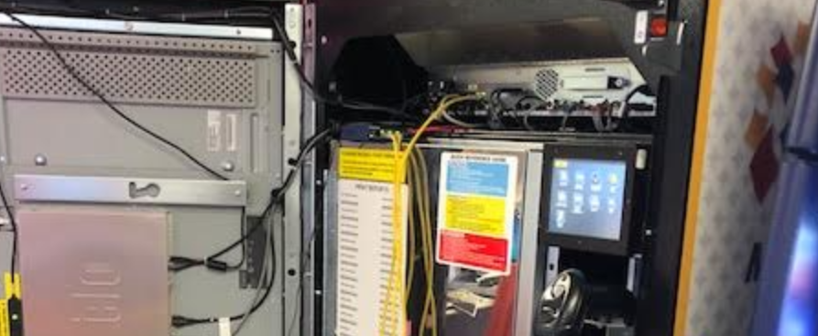First get the connector and yellow wires connect it to desired touch terminal and

Make sure red plug goes into the hub

One yellow to touch and other to your laptop.

Login to winscp.

Use the ip address of the touch

Use login: root password: 2H34diZ

Make sure you choose type SCP only

This will open up winscp

Go to /root/tmp folder and get the esmm.log, debug.log, esmmplayer.log.

Go to Accounting folder and get OGI.log and Engine.log

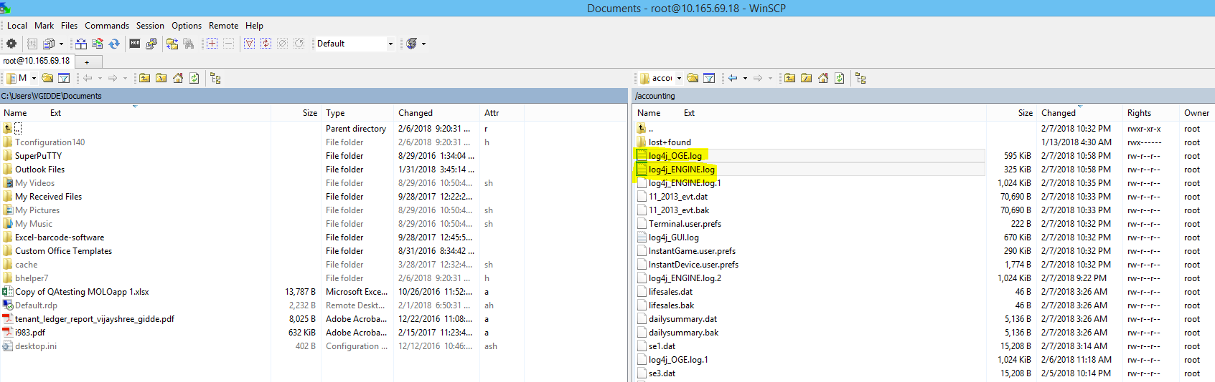Get the logs and give it to the developer